POSTS AND TELECOMMUNICATIONS
INSTITUTE OF TECHNOLOGY

FACULTY OF INFORMATION TECHNOLOGY



REPORT
Analysis and Design of Information Systems
Class: E22HTTT
Project group: 3
Project name: Cinema Management System
Student name: Tran van Hoang
Topic number: 13

Finalized report

Table of Content
Table of Content 2
Subject No. 13 3
I. Requirement 4
1. Build the glossary list 4
2. Project information: 8
3. Build use case diagrams: 12
II. Analys 16
1. Write scenario for each module 16
2. Entity class diagram 20
3. Module class diagram 23
State Diagram for two module 30
5. Communication diagram 31
III.Design 36
1. Entity class for system 36
2. Database design 37
3. Sequence diagram 42
4. Class diagram 43
5. Packet diagram 45
6. Deployment diagram 46

Subject No. 13
Duration: 90 minutes

A cinema management system could be used by management staff, saler and customers:
- Management staff: view the types of statistics: movies, customers and revenue. Schedule showtimes, manage movie and theater information (add, edit, delete).
- Saler: selling tickets at the counter to customers, issuing membership cards to customers
- Customer: register for membership, search, buy tickets online, buy tickets at the counter

Considering two modules and answering questions
- Management staff adds movie information: selects the movie information management menu → selects the function to add movie information → enters movie information and clicks add → the system saves to the database.
- Customer purchases online ticket: selects the ticket purchase menu → selects a movie from the list → selects a viewing time → selects a seat → Enters the loyalty card code (if any) and confirms ticket purchase → pays → prints system tickets and invoices.
Question
Toàn bộ nội dung như đã yêu cầu trong quá trình học:
- Đặc tả
- Phân tích
- Thiết kế
- Lập trình (ảnh các giao diện; ảnh thể hiện cấu trúc file của project trong editor; link source codes theo deadline - nếu ngày add/edit sau deadline coi như không có code)
- Tự đánh giá bài làm của mình vào link google form: https://forms.gle/YoCKoiwT39pgqhfa6

.......
LƯU Ý:
- đặt tên file là Mã đề_Mã sinh viên.docx (ví dụ đề 11 là 11D22DCCN123.docx)

Requirement

1. Build the glossary list
(Danh từ và động từ)
Name | Meaning | Type
Actor of system
Administrator | Highest level actor of the system can do all the function/action of system | Actor
Management staff | who view the types of statistics: movies, customers and revenue. Schedule showtimes, manage movie and theater information (add, edit, delete). | Actor
Saler | staff selling the tickets and issuing membership card | Actor
Offline Customer | Customers buy tickets directly at the cinema. Information about these customers can be inserted to system by saler. | Actor
Payment gateway | a technology service that securely authorizes and processes electronic transactions, acting as a secure digital intermediary between a merchant and their customers' banks and payment processors | Actor
Online Customer | End user who can registers membership card and purchases ticket online through Movie ticket selling website with an account. | Actor
Member | Customer who registered the membership card | Actor
Object of Movie-related
Movie | Film shown at the cinema. A cinema can show many movies, a movie can be shown in many cinema halls | Object
Movie information | data about movie (ID, tittle, genre, duration, type, age range, actors list, director, brief_summary, rating) | Object
Movie List | a temporary List of movies currently available for viewing and ticket purchase | Object
showtimes | Scheduled times when and where movies are show. Mangement staff will choose times in day and showing room for every movie. | Object
Cinema and theater object
Cinema management system | The system that manages the cinemas, supporting the operation and administration of all activities | Object
Showing room | a room can show a movie in one show time at a theater. a theater contain many showing rooms. These room contain many seats and can show many movies in different times. | Object
Seat | A physical place in the theater can be booked by online and offline customer. Each seat can be use in one show time. A seat contains: theater, showing room, place in room. | Object
showtimes | Scheduled times when and where movies are show. Mangement staff will choose times in day and showing room for every movie. | Object
Ticket and membership object
Ticket purchase menu | Menu showing movies information for customer to choose then booking ticket for that movie a menu will show movies information, showtimes in day grouped by theater in system for the following movie, price of ticket. | Object
Ticket | Proof of purchase which contain values: theater, showing room, seat, showtime, price, level of ticket, movie tittle ticket can booking online and purchase directly at the counter in theater. price of a ticket can be changed by the administrator of the theaters system base on the popular and the attraction of a movie. Each ticket linked to exactly one seat in one show time. | Object
Membership card | Membership card that provides benefits (discount, points, barcode). Each ticket was bought, member will took a amount of point base on price of ticket. | Object
Discount | The proof of the reduce of price which membership can exchange by member point in membership card.  Customer can collect point by buying ticket and have point equal to 5% of the amount of money the pay. | Object
Other Object
Account | there are 3 types of account are manager, staff and customer account.  Accounts of customers created on website of theater by themselves and can book ticket, watch showtimes schedule.  Account of saler are staff account with saler staff account created by administrators, staff account can log in to POS machine (point of sale machine) for selling ticket.  Account for management staffs are staff accounts and are created by administrator, these account can | Object
statistic | Reports on movies rating, amount of customers, and revenue | Object
Revenue | Total amount of money from ticket sales and other income in theater | Object
Action of human
Schedule showtimes | Action of management staff which determine showtimes of movies | Action
Online book ticket | Action of customer which will choose theater, showtimes and emty seat(which was not booked online or its ticket was not purchased at counter) ticket online and then pay for ticket. | Action
Select movie from list | Action of customer to choose movie in the menu on interface of website to see the detail information of movie and then book the ticket. | Action
Select view time | Select the showtimes of a movie in day. starting time of these movie must later than at present. Waiting time for the booking movie will set up by the management staff. | Action
Select seat | Action of customer to choose empty seat in cinema hall | Action
Enter membership code | Customer write membership code on the membership card to website for discount and more benefit. | Action
print online ticket and invoice | return a pdf ticket and invoice for customer who booking online for printing. | Action
paying | Action of customer to purchase ticket.  if customer paying online there will only bank transfer method. After transfer, system will transfer money to payment gateway then transfer back to theater system.  else if customer purchase ticket at the counter, there will all payment methods. | Action
Add movie information | Action of the management staff to add a new movie into the system.  The staff selects the movie information management menu, chooses the add movie function, enters movie information and confirms. The system validates the data and saves the new movie information into the database, making it available for scheduling and ticket sales. | Action
Action of sytem
System save movie information to database | Action of system which will save movie information inserted by management staff to Movie List in system database. | Action
Transfer to payment gateway | After user(online customer) transfer money to payment gateway (use transfer method when paying for online ticket) system transfer to a intermediary gateway. | Action

2. Project information:
- Objective
The objective of the Cinema Management System is to:
- Automate the process of managing movies, showtimes, ticket sales, and membership.
- Enable management staff to easily add, edit, delete, and schedule movies.
- Support salers in selling tickets at the counter and issuing membership cards.
- Allow customers (both online and offline) to quickly purchase tickets, select showtimes, choose seats, and make payments.
- Provide statistical reports (movies, customers, and revenue) for management.
- Scope
Only authorized managers, sales staff, and customers are allowed to operate and use the software.
- System members:
+ Log in
+ Log out
+ Change personal password
- Managers:
+ Manage customers account (error, add, edit, delete)
+ Manage movie information (add, edit, delete movie)
+ View statistics: movies, customers, and revenue
+ Schedule showtimes.
- Sales staff:
+ Sell tickets at the counter to customers
+ Issue membership cards to customers
- Customers are allowed to:
+ Register for membership
+ Search for movie
+ Buy tickets online, buy tickets at the counter
+ Looking for seat
+ Paying

- How do the modules work
- Management staff adds movie information
  - Staff selects the movie information management menu.
  - Chooses the add movie function.
  - Enters movie details (title, genre, duration, director, actors, age range, summary).
  - Confirms → The system validates data and saves the new movie to the Movie List in the database.
  - The new movie becomes available for scheduling and ticket sales.
- Customer purchases online ticket
  - Customer logs in → selects the ticket purchase menu.
  - Chooses a movie from the list → selects a showtime → selects a seat.
  - Enters membership card code (if any).
  - Confirms the purchase → makes payment (bank transfer).
  - The system records the transaction, generates a Ticket and Invoice, and provides a PDF for printing.
- Information about objects
1. Information related to people
- Management staff: name, login name, password, role, date of birth, phone number, email, address
- Saler (Sales staff): same as management staff
- Online Customer: full name, login name, password, role, date of birth, phone number, email, address, account information
- Offline Customer: full name, phone number, email (their information can be inserted into the system by saler)
- Member: customer information + membership card (membership code, accumulated points, discount, barcode)

2. Information related to cinema facilities
- Cinema / Theater: cinema name, location, description
- Showing room: room code, capacity, description (a theater contains many showing rooms)
- Seat: seat code, theater, showing room, place in room, status (booked / available)

3. Information related to movies
- Movie: movie code, title, genre, duration, type, age range, actors list, director, brief summary, rating
- Movie information: detailed metadata about a movie (ID, title, genre, duration, etc.)
- Movie list: list of movies currently available for scheduling and ticket sales
- Showtime: showtime code, date, time, showing room, linked movie
- Ticket: ticket code, movie title, theater, showing room, seat, showtime, ticket price, ticket level, description
- Ticket purchase menu: menu displaying movies, showtimes, prices for customers to choose when booking
- Invoice: invoice code, list of tickets, total price, creation date

4. Information related to statistics
- Statistic: reports generated by the system
- Movie statistics (ratings, revenue by movie)
- Customer statistics (number of customers, revenue by customer)
- Revenue statistics (total amount of money from ticket sales and other income)

5. Relationships among objects
- A Movie has multiple Showtimes, and each Movie is linked to a Showing room and just change whenever there are issues.
- A Showing room contains many Seats, and each Seat is assigned to exactly one Ticket in one showtime.
- A Customer can become a Member (owns a Membership card).
- A Member earns points when purchasing Tickets.
- A Ticket is linked to a Movie, Showtime, Seat, and Customer information.
- Statistics and Revenue are generated by the system based on Ticket sales and customer activity.

3. Build use case diagrams:
- General usecase diagram
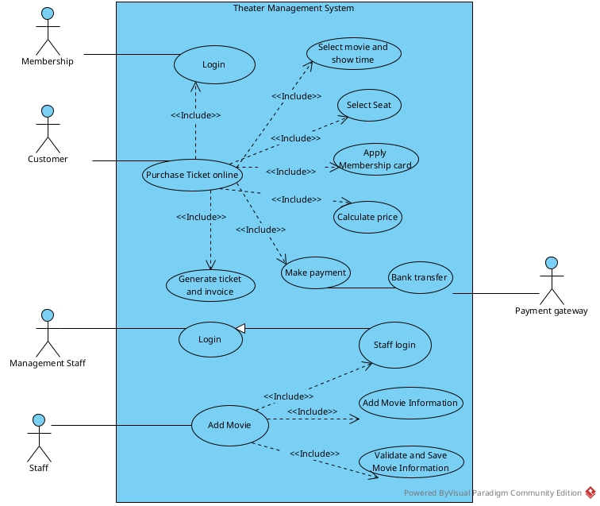
Functionality per Actor:
- Membership: This actor interacts with the system to perform the Login use case.
- Customer: This actor interacts with the system to perform the Purchase Ticket online use case.
- Management Staff: This actor interacts with the system to perform the Login use case.
- Staff: This actor interacts with the system to perform the Add Movie use case.
- Payment gateway: This external actor interacts with the system during the Bank transfer use case.
Description:
- Login / Staff login:
  - Login: This is the general use case for system authentication. It is used directly by the Membership and Management Staff actors. It is also a required step (<<Include>>) for the Purchase Ticket online process.
  - Staff login: This is a specific type (generalization) of Login intended for staff members. It is a required step (<<Include>>) for the Add Movie process.
- Add Movie:
  - This is the main use case initiated by the Staff actor. It encapsulates the entire process of adding a new movie. To be completed, it must include the following required functions:
  - <<Include>> Staff login: The staff member must be authenticated before they can add a movie.
  - <<Include>> Add Movie Information: This use case allows the staff to enter the specific details of the movie (e.g., title, synopsis, rating).
  - <<Include>> Validate and Save Movie Information: This use case represents the system's internal functions to verify that the entered data is valid and then save the information to the database.
- Purchase Ticket online:
  - This is the main use case initiated by the Customer actor. It represents the complete process of a customer booking a ticket. It includes several mandatory sub-functions:
  - <<Include>> Login: The customer must be logged in to their account to proceed with the purchase.
  - <<Include>> Select movie and show time: Allows the customer to browse the schedule and choose a specific screening.
  - <<Include>> Select Seat: Allows the customer to view a seating map and select their desired seat(s).
  - <<Include>> Apply Membership card: Allows the customer to enter their membership details to receive a discount.
  - <<Include>> Calculate price: The system's function to compute the final cost, including any applied membership discounts.
  - <<Include>> Make payment: The general process for handling the transaction.
  - <<Include>> Generate ticket and invoice: After payment is successful, the system creates the official ticket and a receipt for the customer.
- Make payment / Bank transfer:
  - Make payment: This is the general payment function included in the "Purchase Ticket" flow.
  - Bank transfer: This is a specific type (generalization) of Make payment. This particular method requires communication with the external Payment gateway actor to process the transaction.
- Add movie information
Use case:
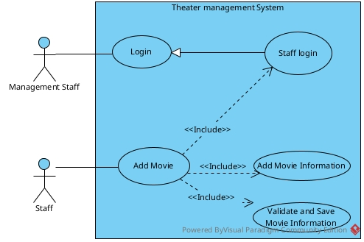
Functionality per Actor:
- Management Staff: This actor interacts with the system to perform the Login use case.
- Staff: This actor interacts with the system to perform the Add Movie use case.
Description:
- Login / Staff login: The Login use case represents the general function for system authentication, which is directly used by the Management Staff. The Staff login use case is a specific type (generalization) of Login required for staff members.
- Add Movie: This is the main use case initiated by the Staff actor. It encapsulates the entire process of adding a new movie to the system.
- Add Movie Information: This use case allows the staff to enter the specific details of the movie (e.g., title, synopsis, duration, rating).
- Validate and Save Movie Information: This use case represents the system's internal functions to verify that the entered data is valid and then save the information to the database.
Build use case diagram for module Purchase ticket online
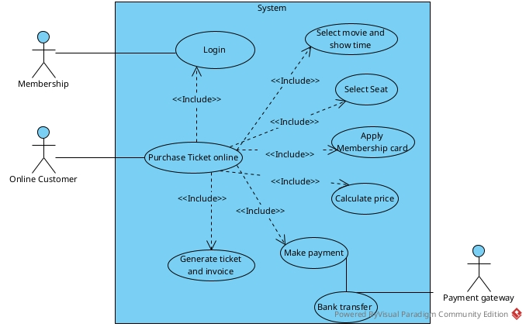

Functionality per Actor:
- Membership: This actor interacts with the system to perform the Login use case.
- Online Customer: This actor interacts with the system to perform the Purchase Ticket online use case.
- Payment gateway: This is an external actor that interacts with the Bank transfer use case to process payments.
The use cases are described as follows:
- Login: This use case allows a user (either a Membership actor or as part of the purchase flow) to authenticate themselves.
- Select movie and show time: This use case allows the customer to browse and select a movie and a specific showtime.
- Select Seat: This use case allows the customer to pick their desired seat(s) from the theater map.
- Apply Membership card: This use case allows the customer to enter their membership details, likely to apply discounts or earn loyalty points.
- Calculate price: This use case represents the system's function to compute the total cost based on the selected tickets and any applied promotions.
- Make payment: This use case encapsulates the process of the customer paying for the tickets. It is further specialized into Bank transfer.
- Generate ticket and invoice: This use case represents the system's function to create the digital ticket and a receipt after payment is successfully confirmed.
- Bank transfer: This use case is a specific type (generalization) of Make payment, which interacts with the external Payment gateway to complete the transaction.

II. Analys

Write scenario for each module
Scenario for Module add movie information
Usecase | Add Movie Information
Actor | Management staff
Precondition | The management staff is logged in and has access to the movie management menu.
Post condition | The new movie information is successfully stored in the database.
Scenario | 1. Management staff selects the 'Movie Management' menu.  2. Management staff selects the 'Add Movie' button.  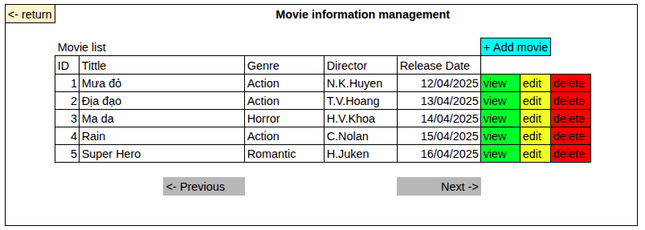  3. Management staff enters movie details (ID, tittle, genre, duration, type, age range, actors list, director, brief_summary)  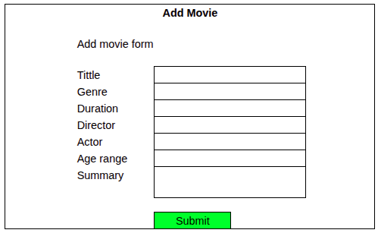  4. Management staff clicks the 'Submit' button.  5. System validates input and saves the new movie information to the database.  6. System displays confirmation message.  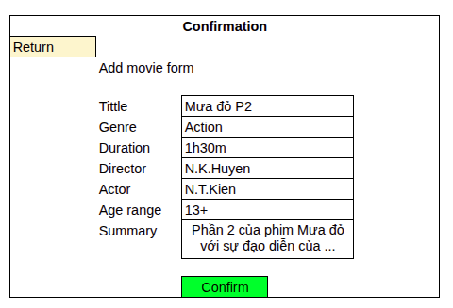
Exception | 1. Movie information existed in database (duplicate)  2. Database connection error  3. Missing required fields

Scenario v1 for module Purchase ticket online

Usecase | Purchase ticket online
Actor | Online Customer
Precondition | Customer has an active account and internet access
Post condition | The new movie information is successfully stored in the database.
Scenario | 1. Customer selects 'Buy Ticket' in main menu.  2. Customer find and selects a movie from the list with “Choose” button  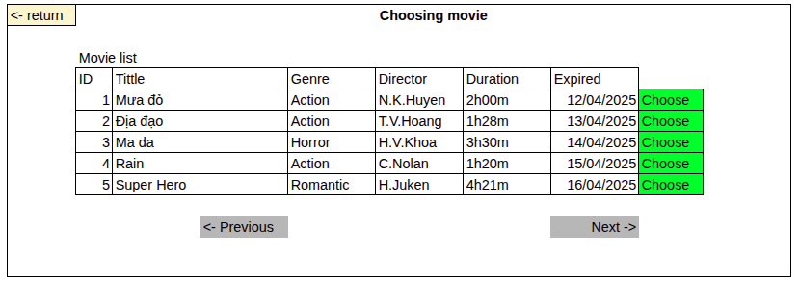  3. Customer selects a viewing time.  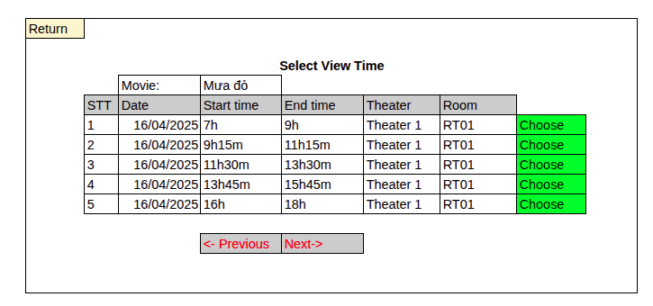  4. Customer selects a seat.  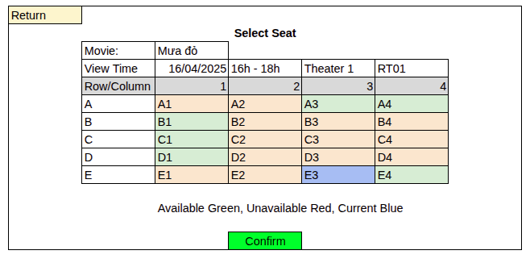  5. Auto enters membership card code.  6. Customer confirms ticket purchase.  7. System calculates price (apply discount if loyalty card is valid).  8. Customer makes payment.  9. System generates and prints the ticket and invoice.
Exception | 1. Seat is no longer available  2. Invalid loyal code  3. Payment failure  4. System error while generating ticket

Entity class diagram
- Step 1: System Description
  - The system is a comprehensive web-based platform for managing a cinema. It must support multiple user roles, which are defined by a main User class that generalizes into UserCustomer, UserSaler, and UserManager. A UserCustomer can optionally have a Membership for discounts. The core function for customers is buying a Ticket. This process involves selecting a Movie and a Showtime. A Showtime is a specific screening of a Movie in a particular TheaterRoom. Theaters (the physical locations) are composed of multiple TheaterRooms, and each TheaterRoom is composed of multiple Seats. To manage inventory, the system uses a ShowtimeSeat entity, which links a specific Seat to a specific Showtime and tracks its status (e.g., available, booked). When a Ticket is purchased, it is linked to one UserCustomer, one specific ShowtimeSeat, and a Payment record. The Payment process is robust, linking to a PaymentMethod (e.g., bank, momo), which in turn uses a Payment_Gateway to process the transaction.
- Step 2: Extract Nouns
  - Nouns related to People: User, UserCustomer, UserSaler, UserManager, Membership.
  - Nouns related to Things/Location: System, platform, cinema, Ticket, Movie, Showtime, Theater, TheaterRoom, Seat, ShowtimeSeat.
  - Nouns related to Information/Process: Role, discount, status, Payment, PaymentMethod, Payment_Gateway, Gateway (connection).
- Step 3: Evaluate and Select Nouns (as Entities and Attributes)
  - Abstract nouns (discarded or became attributes): System, platform, cinema, role, discount, status.
  - Nouns related to People (Entities):
  - User -> User Class: The base class for all users. Attributes: userID, fullname, username, password_hashed, email, phone_number, role, etc.
  - UserCustomer -> UserCustomer Class: Inherits from User. Attributes: CusID. Has an association with Membership.
  - UserSaler -> UserSaler Class: Inherits from User. Attributes: SID, wage, joinDate.
  - UserManager -> UserManager Class: Inherits from User. Attributes: SID, wage, joinDate, salers_managed.
  - Membership -> Membership Class: Attributes: card_code, discount, regisDate, level.
  - Nouns related to Things/Process (Entities):
  - Movie -> Movie Class: Attributes: movieID, title, ageRange, director, summary, actor, rating.
  - Theater -> Theater Class: Attributes: TheaterID, address. (Composition of TheaterRoom).
  - TheaterRoom -> TheaterRoom Class: Attributes: RoomID, label. (Composition of Seat).
  - Seat -> Seat Class: Attributes: SeatID, row, column, type, label.
  - Showtime -> Showtime Class: Attributes: showtimeID, start, end. (Links Movie and TheaterRoom).
  - ShowtimeSeat -> ShowtimeSeat Class: This is a critical association class (or "inventory" entity). Attributes: SSID, status. (Links Seat and Showtime).
  - Ticket -> Ticket Class: The central transaction entity. Attributes: ticketID, ticketCode, price, purchase_time. (Links Payment, UserCustomer, Movie, and ShowtimeSeat).
  - Payment -> Payment Class: Attributes: paymentID, amount, status.
  - PaymentMethod -> PaymentMethod Class: Attributes: PMID, method, account.
  - Payment_Gateway -> Payment_Gateway Class: Attributes: gateName, apiEndpoint, apiKey.
  - Gateway -> Gateway Class: Attributes: con (connection string/object).
- Step 4: Determine Cardinality (Relationships)
  - User has an inheritance (generalization) relationship with UserCustomer, UserSaler, and UserManager.
  - Theater (1) - (n) TheaterRoom (A theater has many rooms).
  - TheaterRoom (1) - (n) Seat (A room has many seats).
  - Movie (1) - (n) Showtime (A movie can have many showtimes).
  - TheaterRoom (1) - (n) Showtime (A room can host many showtimes).
  - Showtime (1) - (n) ShowtimeSeat (A showtime has many seats for sale).
  - Seat (1) - (n) ShowtimeSeat (A physical seat is part of many different showtimes).
  - UserCustomer (1) - (1) Membership (A customer has one membership).
  - UserCustomer (1) - (n) Ticket (A customer can buy many tickets).
  - ShowtimeSeat (1) - (1) Ticket (A ticket is for one specific seat at one show).
  - Payment (1) - (1) Ticket (A ticket has exactly one payment).
  - Payment (1) - (1) PaymentMethod (A payment is made via one method).
  - PaymentMethod (1) - (1) Payment_Gateway (A method uses one gateway).
  - Payment_Gateway (1) - (1) Gateway (A gateway has one connection).
- Step 5: Determine Object Relationships (Aggregation/Composition)
  - Composition (black diamond - "is composed of"):
    - Theater is composed of TheaterRooms.
    - TheaterRoom is composed of Seats.
    - Showtime is composed of ShowtimeSeats.
  - Aggregation (white diamond - "is part of" / "has a"):
    - Ticket is an aggregation of Payment, UserCustomer, Movie, and ShowtimeSeat.
    - Payment is an aggregation of PaymentMethod.
    - PaymentMethod is an aggregation of Payment_Gateway.
    - Payment_Gateway is an aggregation of Gateway.
    - Theater is an aggregation of Movies (the MovieList attribute implies this).
    - UserCustomer has an association with Membership.
Entity diagram
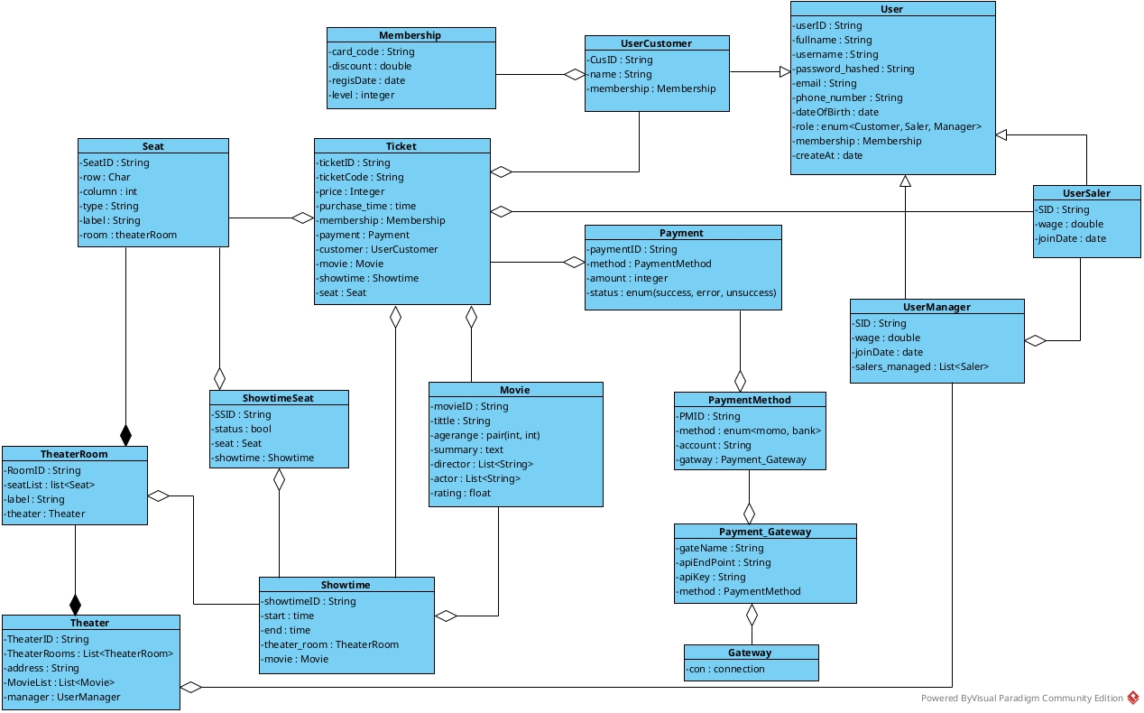

Module class diagram
Module add movie information
Nouns related to people:
- Manager (In diagram: UserManager)
Nouns related to objects:
- Movie (In diagram: Movie)
- Theater (In diagram: Theater)
Analysis of UI Flow and Corresponding Methods
1. Main Cinema Interface (GDChinhrap012)
- Component:
  - Select "Movie Info Management" function: type submit
- Analysis:
  - This action, performed by the UserManager, leads to the Movie Management interface.
2. Movie Management Interface (GDQuanlithongtinphim012)
- Components:
  - Select "Add Movie Information" function: type submit
  - Movie list display: input
- Analysis (Data Requirement):
  - To display the existing list of movies on this management screen.
- Proposed Method (Mapped from Diagram):
  - Method on diagram: +getMovieList()
  - Input: (none)
  - Output: List<Movie> (Returns a list of all current movies).
  - Assigned to class (in diagram): Movie
3. Add Movie Information Interface (GDThemthongtinphim012)
- Components:
  - Movie info input fields (title, summary, etc.): output
  - "Add Movie" button: type submit
- Analysis (Data Requirement):
  - When the UserManager clicks the "Add Movie" button, the system must take all the data from the input fields, validate it, and save it. This diagram uses a "Controller" pattern where the UserManager class handles the use case.
- Proposed Method (Mapped from Diagram):
  - Method on diagram: +addMovieInformation()
  - Input: title: String, summary: text, director: List<String>, actor: List<String>, rating: float, etc. (All data from the UI form).
  - Output: boolean (Returns true for success, or false for failure/duplicate).
  - Assigned to class (in diagram): UserManager
Internal Methods (Called by addMovieInformation)
The +addMovieInformation() method will, in turn, use the methods on the Movie entity to complete its task.
1. Internal Step 1: Check for Duplicates
- Analysis:
  - Before saving, the system must check if this movie already exists.
- Proposed Method (Mapped from Diagram):
  - Method on diagram: +checkDuplicate()
  - Input: title: String (or another unique identifier from the input data).
  - Output: boolean (true if a duplicate is found, false otherwise).
  - Assigned to class (in diagram): Movie
2. Internal Step 2: Save the New Movie
- Analysis:
  - If no duplicate is found, the system saves the new movie. The addMovieInformation method would first create a new Movie object (newMovie = new Movie(...)) and then call its save method.
- Proposed Method (Mapped from Diagram):
  - Method on diagram: +addMovie()
  - Input: (none) (This method is called on the new Movie object instance, e.g., newMovie.addMovie()).
  - Output: boolean (Success/failure of the database save operation).
  - Assigned to class (in diagram): Movie

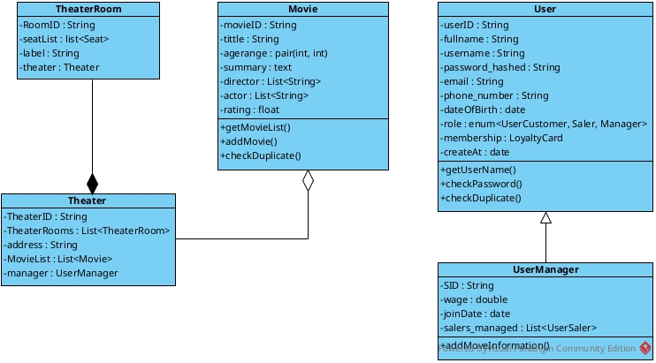
Module Purchase ticket online
Nouns related to people (Các danh từ liên quan đến người):
- Customer (Trong sơ đồ: UserCustomer)
- User (Trong sơ đồ: User)
Nouns related to objects (Các danh từ liên quan đến vật):
- Movie (Trong sơ đồ: Movie)
- Showtime (Trong sơ đồ: Showtime)
- Seat (Trong sơ đồ: Seat)
- ShowtimeSeat (Trong sơ đồ: ShowtimeSeat)
- Ticket (Trong sơ đồ: Ticket)
- Payment (Trong sơ đồ: Payment)
- Payment Method (Trong sơ đồ: PaymentMethod)
- Loyalty Card (Trong sơ đồ: LoyaltyCard)
Analysis of UI Flow and Corresponding Methods (Phân tích luồng UI và các phương thức tương ứng)
1. Login Interface (GDDangnhap012)
- Components (Thành phần):
  - Trường nhập Username: output
  - Trường nhập Password: output
  - Nút "Login": type submit
- Analysis (Data Requirement):
  - Khi UserCustomer nhấn "Login", hệ thống phải xác thực thông tin đăng nhập.
- Proposed Method (Mapped from Diagram):
  - Method on diagram: +Login()
  - Input: username: String, password: String (Dữ liệu từ các trường output)
  - Output: UserCustomer (hoặc boolean cho biết thành công)
  - Assigned to class (in diagram): UserCustomer
- Internal Methods (Called by Login):
  - Phương thức +checkPassword() trên lớp User sẽ được gọi nội bộ để so sánh mật khẩu đã hash.
2. Movie Selection Interface (GDChonphim012)
- Components (Thành phần):
  - Hiển thị danh sách phim: input (người dùng chọn 1)
- Analysis (Data Requirement):
  - Để hiển thị danh sách các phim (Movie) hiện đang có cho khách hàng lựa chọn.
- Proposed Method (Mapped from Diagram):
  - Method on diagram: +getMovieList()
  - Input: (none)
  - Output: List<Movie> (Trả về danh sách tất cả các phim)
  - Assigned to class (in diagram): Movie
3. Showtime Selection Interface (GDChonxuatchieu012)
- Components (Thành phần):
  - Hiển thị danh sách suất chiếu (cho bộ phim đã chọn): input (người dùng chọn 1)
- Analysis (Data Requirement):
  - Sau khi một Movie được chọn, hệ thống phải hiển thị tất cả các suất chiếu (Showtime) có sẵn cho bộ phim đó.
- Proposed Method (Mapped from Diagram):
  - Method on diagram: +getShowtimeList()
  - Input: Movie (hoặc movieID từ phim đã chọn)
  - Output: List<Showtime>
  - Assigned to class (in diagram): Showtime
4. Seat Selection Interface (GDChonghe012)
- Components (Thành phần):
  - Hiển thị sơ đồ ghế: input (người dùng chọn 1 hoặc nhiều ghế)
  - Nút "Confirm": type submit
- Analysis (Data Requirement):
  - Để hiển thị sơ đồ ghế cho Showtime đã chọn, bao gồm trạng thái của từng ghế (trống hay đã đặt). Dữ liệu này đến từ lớp ShowtimeSeat.
- Proposed Method (Mapped from Diagram):
  - Method on diagram: (Không có phương thức get rõ ràng. Đây là một truy vấn logic).
  - Input: showtimeID (từ Showtime đã chọn).
  - Output: List<ShowtimeSeat> (Danh sách các đối tượng ShowtimeSeat chứa thông tin Seat và status).
  - Assigned to class (in diagram): ShowtimeSeat (Đây là lớp được truy vấn).
5. Payment Interface (GDThanhtoan012)
- Components (Thành phần):
  - Danh sách phương thức thanh toán: input (người dùng chọn 1)
  - Thông tin thẻ thành viên (LoyaltyCard): input (có thể tự động áp dụng)
  - Nút "Pay": type submit
- Analysis (Data Requirement):
  - Hiển thị các phương thức thanh toán (PaymentMethod) có sẵn (ví dụ: Momo, bank).
- Proposed Method (Mapped from Diagram):
  - Method on diagram: +getPaymentMethodList()
  - Input: (none)
  - Output: List<PaymentMethod>
  - Assigned to class (in diagram): PaymentMethod
6. System Processing (Triggered by "Pay" button)
- Components (Thành phần):
  - (Không có giao diện, đây là logic nghiệp vụ)
- Analysis (Data Requirement):
  - Khi UserCustomer nhấn "Pay", hệ thống sẽ bắt đầu quy trình mua vé. Đây là phương thức cấp cao điều phối toàn bộ hành động.
- Proposed Method (Mapped from Diagram):
  - Method on diagram: +purchaseTicket()
  - Input: Showtime, List<Seat>, PaymentMethod (Dữ liệu thu thập từ các bước trước).
  - Output: Ticket (Trả về vé đã tạo)
  - Assigned to class (in diagram): UserCustomer
- Internal Methods (Called by purchaseTicket())
  - 1. Internal Step 1: Process Payment (Xử lý thanh toán)
    - Analysis: Gọi PaymentGateway và lưu lại giao dịch Payment.
    - Method on diagram: +insertPayment()
    - Input: Payment (Đối tượng Payment được tạo với amount, method, và status).
    - Output: boolean (Thành công/thất bại).
    - Assigned to class: Payment
  - 2. Internal Step 2: Create Ticket (Tạo vé)
    - Analysis: Nếu thanh toán thành công, tạo bản ghi Ticket.
    - Method on diagram: +insertTicket()
    - Input: Ticket (Đối tượng Ticket được tạo với UserCustomer, Showtime, Seat, Payment).
    - Output: boolean (Thành công/thất bại).
    - Assigned to class: Ticket
  - 3. Internal Step 3: Update Seat Status (Cập nhật ghế)
    - Analysis: Đánh dấu Seat đã chọn là đã đặt (status = false) trong lớp ShowtimeSeat.
    - Method on diagram: (Không có phương thức update rõ ràng. Logic này sẽ cập nhật thuộc tính status trên (các) đối tượng ShowtimeSeat liên quan và lưu lại).
    - Input: List<ShowtimeSeat>
    - Output: (void)
    - Assigned to class: ShowtimeSeat
7. View Ticket Interface (GDXemve012)
- Components (Thành phần):
  - Hiển thị chi tiết vé: output
  - Nút "Print Ticket": type submit
- Analysis (Data Requirement):
  - Sau khi purchaseTicket() thành công, hiển thị vé cho người dùng. Người dùng có thể chọn in vé.
- Proposed Method (Mapped from Diagram):
  - Method on diagram: +printTicket()
  - Input: (none) (Phương thức này được gọi trên đối tượng Ticket đã được tạo).
  - Output: (void hoặc một tài liệu có thể in)
  - Assigned to class (in diagram): Ticket
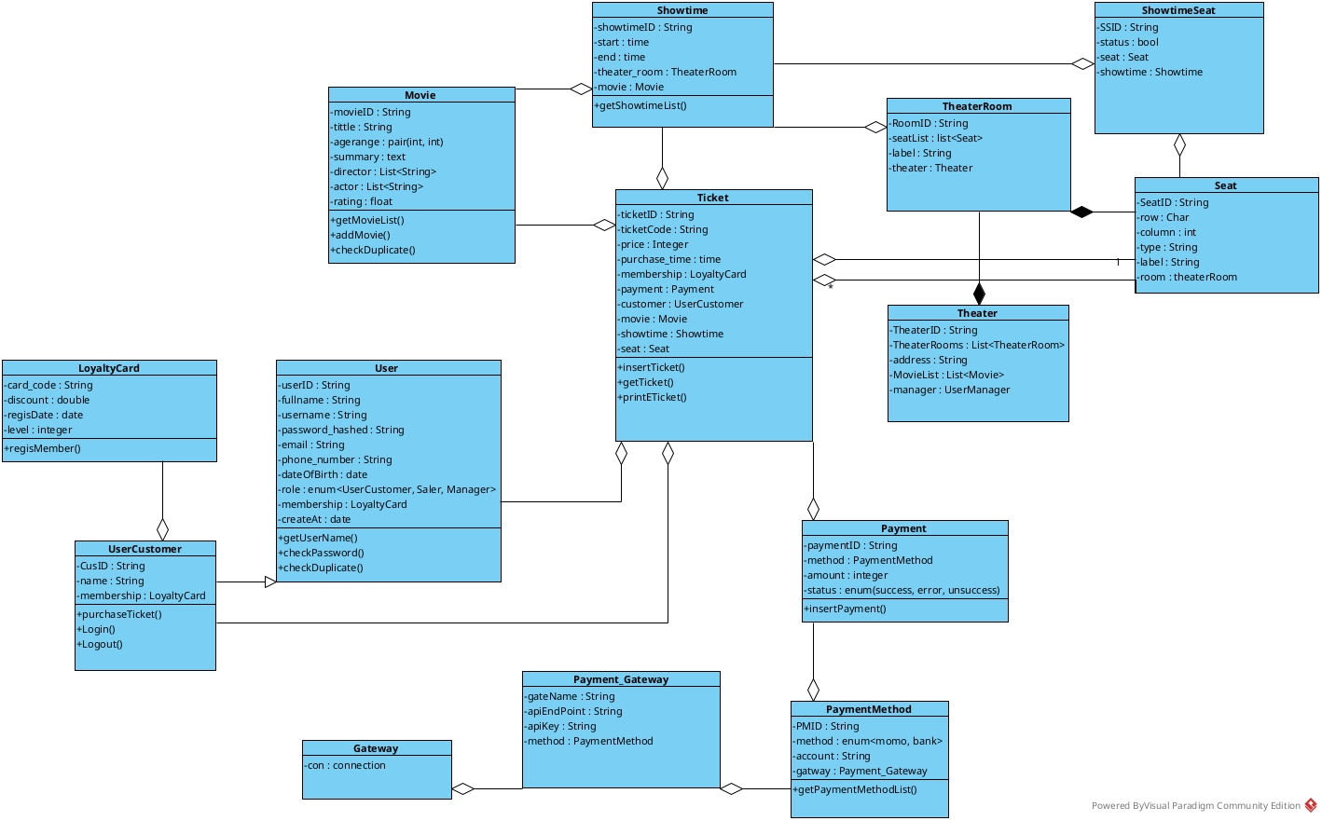

State Diagram for two module
Module Add movie information
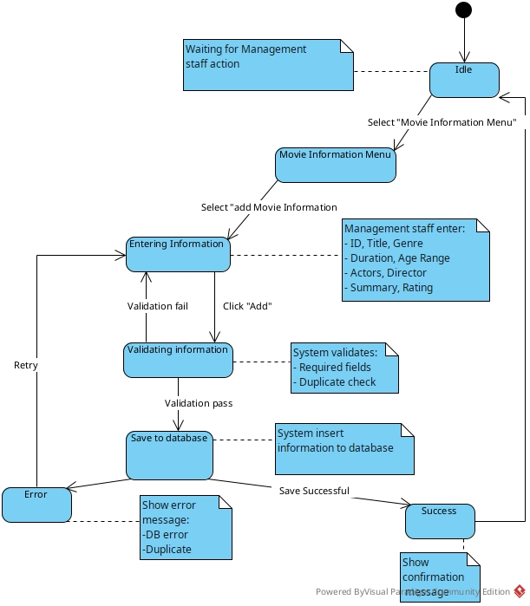

Module Purchase ticket online
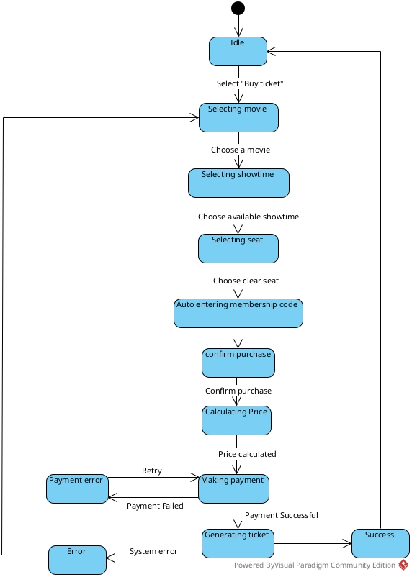

5. Communication diagram
Communication diagram for module 1: Add movie information
Scenario V2 for module Add movie information
- ManagementStaff chooses movie information option
- mainMenu.jsp calls movieInfo.jsp
- movieInfo.jsp calls MovieDAO
- MovieDAO invokes getMovie() method
- MovieDAO calls Movie entity
- Movie entity returns List<Movie>
- MovieDAO returns movie data
- movieInfo.jsp returns display data
- movieInfo.jsp returns control
- ManagementStaff displays movie information
- ManagementStaff clicks "Add Movie" button
- movieInfo.jsp calls addMovie.jsp
- ManagementStaff inserts information and submits
- addMovie.jsp calls MovieController
- MovieController invokes setMovie() on MovieDAO
- MovieDAO calls Movie entity
- Movie entity returns new movie object
- MovieDAO returns status
- MovieController returns result
- addMovie.jsp returns control
- addMovie.jsp calls Confirmation page
- Confirmation page displays success message
- ManagementStaff clicks confirm
- Confirmation page calls MovieController
- MovieController invokes insertMovie() on MovieDAO
- MovieDAO accesses Movie entity
- MovieDAO returns final status
- MovieController returns completion status
- System change back to movie screen after insert movie information

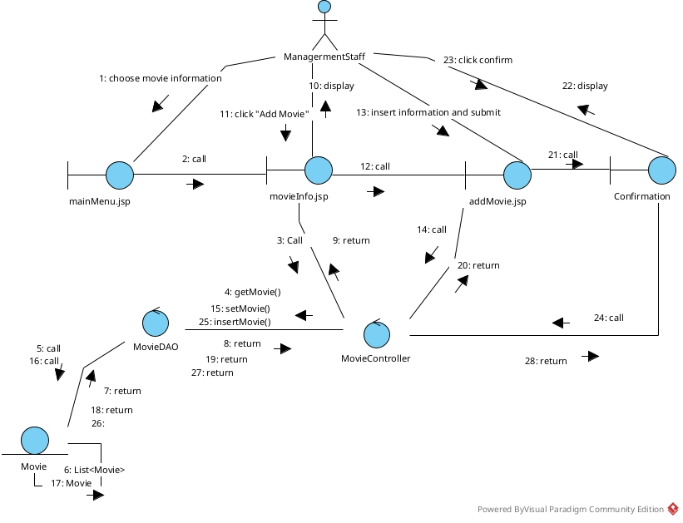
Communication diagramm for Purchase ticket online
Scenario V2 for module purchase ticket online
Phase 1: Select Movie
- Online Customer chooses "Buy Ticket" option
- mainMenu.jsp calls movieScreen.jsp
- movieScreen.jsp calls MovieController
- MovieController invokes doGet() method
- MovieController calls MovieDAO
- MovieDAO invokes getMovieList() method
- MovieDAO accesses Movie entity
- Movie entity returns List<Movie>
- MovieDAO returns movie list
- MovieController returns movie data
- movieScreen.jsp returns and processes data
- movieScreen.jsp displays movie list
- Online Customer chooses one movie
Phase 2: Select Showtime
- movieScreen.jsp calls showtimeScreen.jsp
- showtimeScreen.jsp calls showtimeController
- showtimeController invokes doGet() method
- showtimeController calls ShowtimeDAO
- ShowtimeDAO invokes getShowtimesAvailable() method
- ShowtimeDAO accesses Showtime entity
- Showtime entity returns List<Showtime>
- ShowtimeDAO returns showtime list
- showtimeController returns showtime data
- showtimeScreen.jsp returns and processes data
- showtimeScreen.jsp displays available showtimes
- Online Customer chooses one showtime
Phase 3: Select Seat
- showtimeScreen.jsp calls seatScreen.jsp
- seatScreen.jsp calls seatController
- seatController invokes doGet() method
- seatController calls SeatDAO
- SeatDAO invokes getSeats() method
- SeatDAO accesses Seat entity
- Seat entity returns List<Seat>
- SeatDAO returns seat list
- seatController returns seat data
- seatScreen.jsp returns and processes data
- seatScreen.jsp displays available seats
- Online Customer chooses one or many seats
Phase 4: Calculate Price
- seatScreen.jsp calls PriceCalculator
- PriceCalculator invokes getBasePrice() method
- PriceCalculator invokes applySurcharge() method
- PriceCalculator returns calculated total price
Phase 5: Select Payment Method
- seatScreen.jsp calls paymentMethodScreen.jsp
- paymentMethodScreen.jsp calls PMController
- PMController invokes doGet() method
- PMController calls PMDAO
- PMDAO invokes getPaymentMethod() method
- PMDAO accesses PaymentMethod entity
- PaymentMethod entity returns List<PaymentMethod>
- PMDAO returns payment method list
- PMController returns payment method data
- paymentMethodScreen.jsp returns and processes data
- paymentMethodScreen.jsp displays payment methods with total price
- Online Customer chooses one Payment Method
Phase 6: Process Payment
- paymentMethodScreen.jsp calls paymentScreen.jsp
- paymentScreen.jsp displays payment form
- Online Customer confirms and makes payment
- paymentScreen.jsp calls paymentController
- paymentController invokes doPost() method
- paymentController calls PaymentDAO
- PaymentDAO invokes insertPayment() method
- PaymentDAO accesses Payment entity
- Payment entity returns payment status
- PaymentDAO returns payment result
- paymentController returns payment confirmation
Phase 7: Generate Ticket
- paymentScreen.jsp calls ticketScreen.jsp
- ticketScreen.jsp displays ticket preview
- Online Customer clicks confirm
- ticketScreen.jsp calls ticketController
- ticketController invokes doPost() method
- ticketController calls TicketDAO
- TicketDAO invokes insertTicket() method
- TicketDAO accesses Ticket entity
- Ticket entity returns ticket object
- TicketDAO returns ticket creation status
- ticketController returns ticket result
- ticketScreen.jsp displays final ticket confirmation to Online Customer
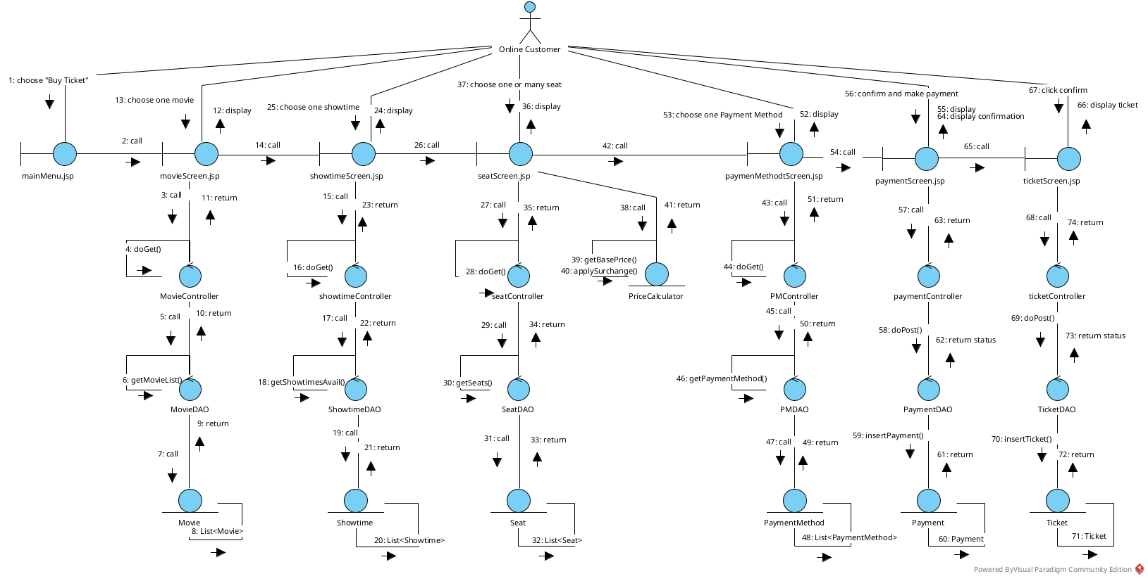

III.Design

Entity class for system
Step 1: Add 'ID' Attributes
- Analysis: Diagram 1 (Baseline) conforms by using primary IDs (e.g., ticketID, movieID). Diagrams 2 & 3 expand on this by adding new role classes (UserManager, UserSaler). These new classes correctly follow the exception rule, inheriting userID and adding a specific role identifier (SID: String) rather than a generic id.
Step 2: Add Java-Type Attributes
- Analysis: Diagram 1 (Baseline) uses standard Java types (String, List, enum). Diagrams 2 & 3 refine this by specifying the User.role as a concrete enum<UserCustomer, Saler, Manager>. A new attribute, Movie.agerange: pair<int, int>, was also added. This pair is an abstraction that must be implemented as a custom Java class (e.g., AgeRange) or as two separate attributes (minAge, maxAge).
Step 4: Add Relationship Attributes
- Analysis: This step reflects the most significant change. Diagram 1 (Baseline) correctly models composition (e.g., Theater has TheaterRooms: List<TheaterRoom>). Diagrams 2 & 3 add new relationship attributes required for system-wide functionality:
  - MovieList: List<Movie>: Added to Theater to support the "Add Movie" module (Aggregation).
  - salers_managed: List<UserSaler>: Added to UserManager to support staff management (Association).

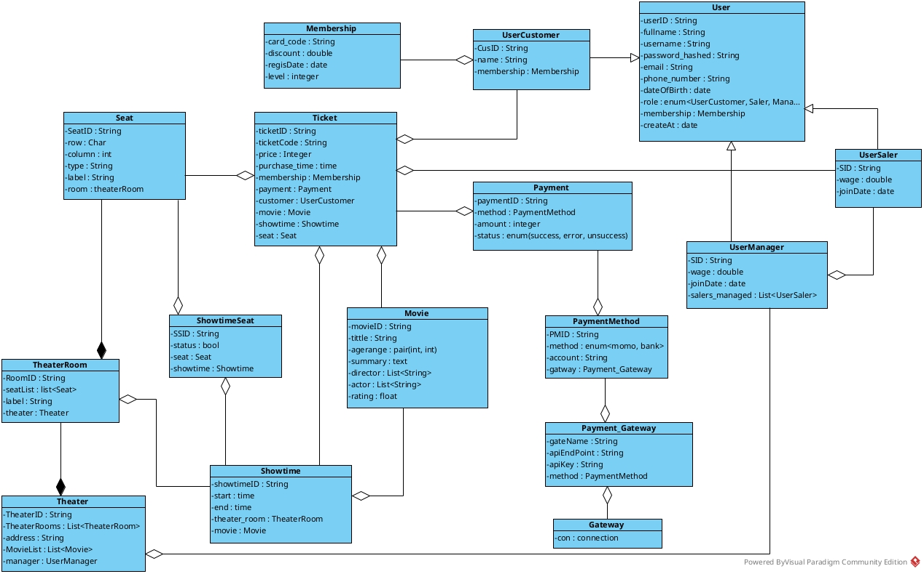

Database design
Step 1: Class-to-Table Mapping
Entity classes in the model are mapped to corresponding tables in the database:
- User Class -> tblUser
- Membership Class -> tblMembership
- Movie Class -> tblMovie
- Actor Class -> tblActor
- Director Class -> tblDirector
- Showtime Class -> tblShowtime
- Theater Class -> tblTheater
- TheaterRoom Class -> tblTheaterRoom
- Seat Class -> Seat
- Ticket Class -> tblTicket
- Payment Class -> tblPayment
- PaymentMethod Class -> tblPaymentMethod
- Association Classes (M:N):
  - Actor_Movie Class -> Actor_tblMovie
  - Director_Movie Class -> Director_tblMovie
  - Showtime_Seat Class -> Showtime_Seat
Step 2: Add Attributes (Columns)
The attributes of each class are converted into columns in the corresponding table, with data types defined:
- tblUser: UserID (varchar), username (varchar), email (varchar), password (varchar), role (varchar), fullName (varchar), phoneNumber (varchar), createAc (date)
- tblMembership: CardCode (varchar), discount (double), regisDate (date), level (integer), tblUserUserID (varchar)
- tblMovie: movieID (varchar), title (varchar), genre (varchar), duration (integer), type (varchar), agerange (integer), briefSummary (varchar), rating (double)
- tblShowtime: showtimeID (varchar), date (date), time (time), MovieMovieID (varchar)
- tblTheater: TheaterID (varchar), theaterName (varchar), location (varchar)
- tblTheaterRoom: RoomID (varchar), RoomName (varchar), capacity (integer), tblTheaterTheaterID (varchar)
- Seat: SeatID (varchar), seatNumber (varchar), status (varchar), type (varchar), tblTheaterRoomRoomID (varchar)
- tblTicket: TicketID (char), price (integer), SeatID (varchar), tblShowtimeShowtimeID (varchar), tblUserUserID (varchar)
- tblPayment: paymentID (varchar), amount (integer), status (varchar), tblTicketTicketID (varchar), tblPaymentMethodPMID (varchar)
- tblPaymentMethod: PMID (varchar), method (varchar), apiKey (varchar), momoApi (varchar), bankApi (varchar)
- tblActor: AID (varchar), fullname (varchar), birthdate (date), debut (date), summary (varchar)
- tblDirector: DID (varchar), fullname (varchar), birthdate (date), debutDate (date), summary (varchar)
- Actor_tblMovie: ActorAID (varchar), tblMovieMovieID (varchar)
- Director_tblMovie: DirectorDID (varchar), tblMovieMovieID (varchar)
- Showtime_Seat: ShowtimeShowtimeID (varchar), SeatSeatID (varchar)
Step 3: Convert Relationships (Cardinality)
Cardinality relationships between classes are converted to relationships between tables:
- 1 tblUser – 1 tblMembership
- 1 tblUser – n tblTicket
- 1 tblMovie – n tblShowtime
- 1 tblTheater – n tblTheaterRoom
- 1 tblTheaterRoom – n Seat
- 1 tblShowtime – n tblTicket
- 1 Seat – n tblTicket (Note: A seat can belong to many tickets for different showtimes)
- 1 tblTicket – 1 tblPayment (Note: Each ticket corresponds to one payment)
- 1 tblPaymentMethod – n tblPayment
- Many-to-Many (M:N) Relationships:
  - n tblMovie – n tblActor (via Actor_tblMovie table)
  - n tblMovie – n tblDirector (via Director_tblMovie table)
  - n tblShowtime – n Seat (via Showtime_Seat table, to track seat status for each showtime)
Step 4: Add Key Attributes (PK, FK)
Primary Keys (PK) and Foreign Keys (FK) are added to represent the links.
- Primary Keys (PK):
  - Unlike the template's exception rule, in this diagram, every entity table has its own primary key (e.g., tblUser PK is UserID, tblMovie PK is movieID, tblTicket PK is TicketID, etc.).
  - The association tables have composite primary keys:
    - Actor_tblMovie: PK is (ActorAID, tblMovieMovieID)
    - Director_tblMovie: PK is (DirectorDID, tblMovieMovieID)
    - Showtime_Seat: PK is (ShowtimeShowtimeID, SeatSeatID)
- Foreign Keys (FK):
  - 1 tblUser – 1 tblMembership -> tblMembership table has FK tblUserUserID (references tblUser.UserID)
  - 1 tblUser – n tblTicket -> tblTicket table has FK tblUserUserID (references tblUser.UserID)
  - 1 tblMovie – n tblShowtime -> tblShowtime table has FK MovieMovieID (references tblMovie.movieID)
  - 1 tblTheater – n tblTheaterRoom -> tblTheaterRoom table has FK tblTheaterTheaterID (references tblTheater.TheaterID)
  - 1 tblTheaterRoom – n Seat -> Seat table has FK tblTheaterRoomRoomID (references tblTheaterRoom.RoomID)
  - 1 tblShowtime – n tblTicket -> tblTicket table has FK tblShowtimeShowtimeID (references tblShowtime.showtimeID)
  - 1 Seat – n tblTicket -> tblTicket table has FK SeatID (references Seat.SeatID)
  - 1 tblTicket – 1 tblPayment -> tblPayment table has FK tblTicketTicketID (references tblTicket.TicketID)
  - 1 tblPaymentMethod – n tblPayment -> tblPayment table has FK tblPaymentMethodPMID (references tblPaymentMethod.PMID)
Step 5: Derived Attributes / Statistics Tables
- Analysis: The provided ERD is an operational data model. It does not contain any statistical tables (e.g., tblRevenueStats, tblMovieStats) or derived attributes.
- Conclusion: Step 5 is not applicable to this diagram as there are no statistics tables to remove.

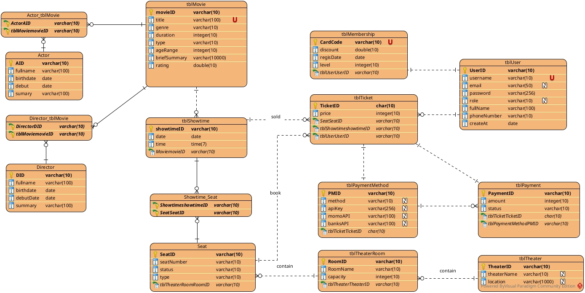

Sequence diagram
Module add movie information
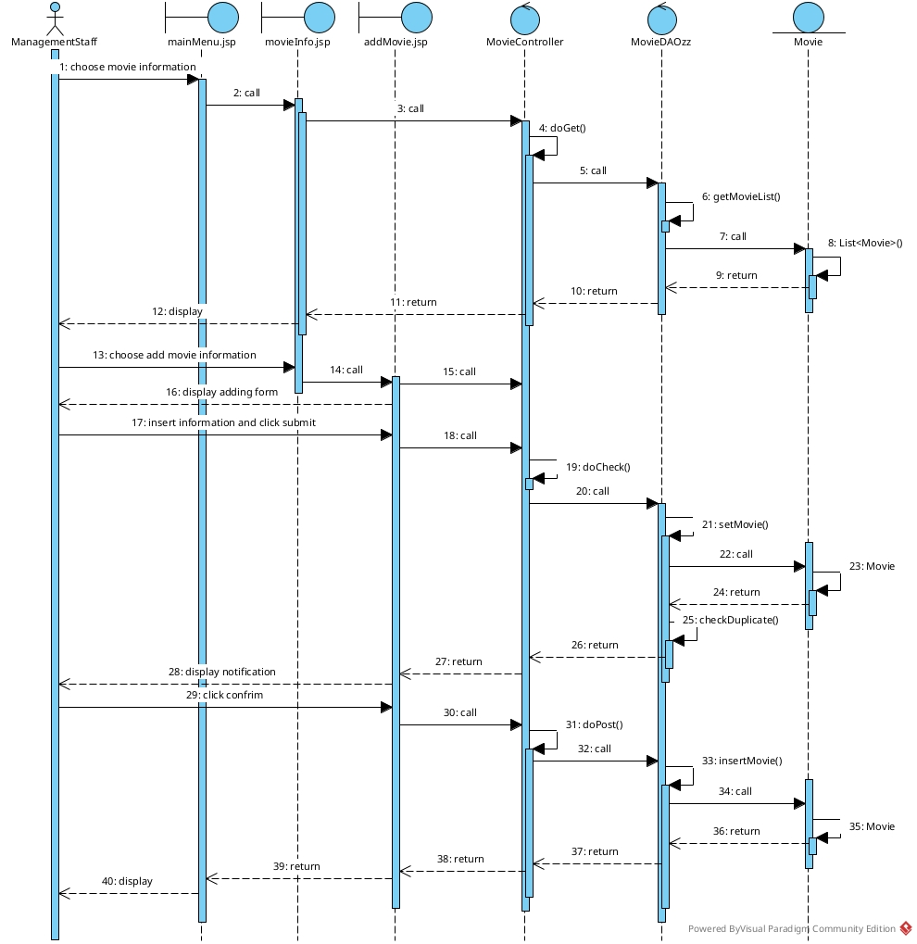
Module purchase ticket online
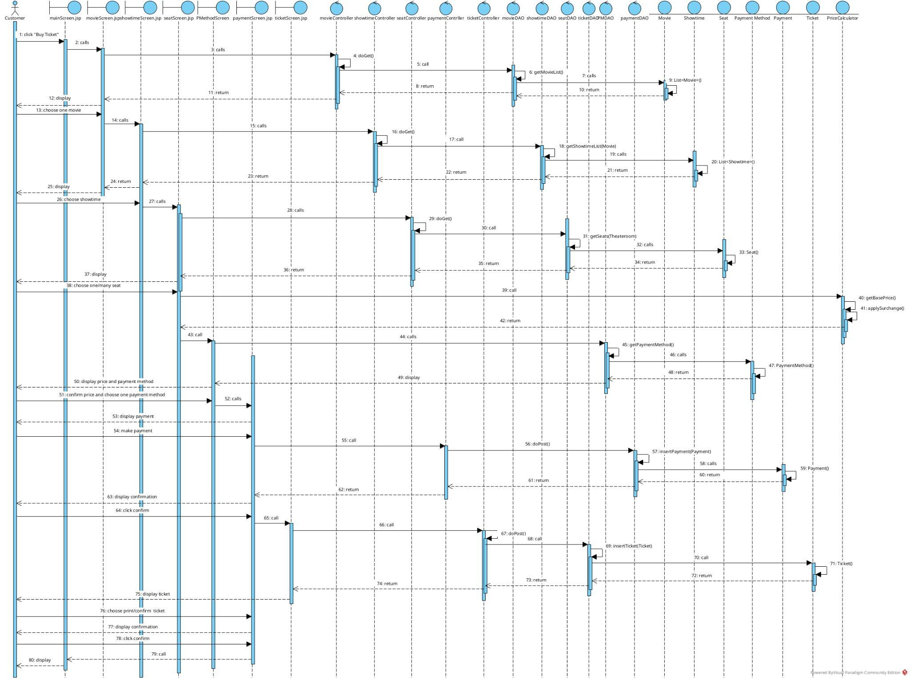

Class diagram
Module Add movie information
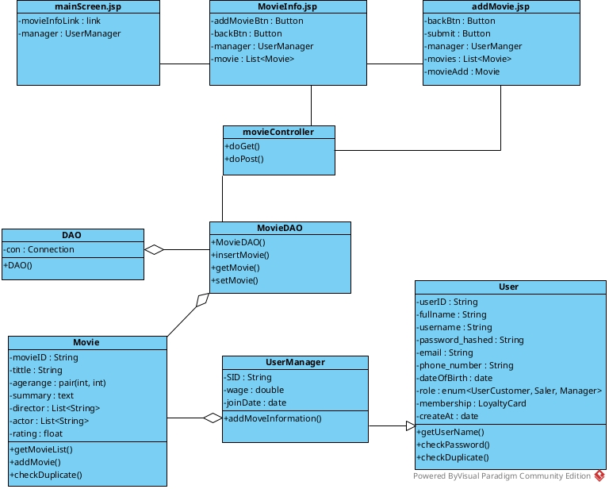
Module purchase ticket online
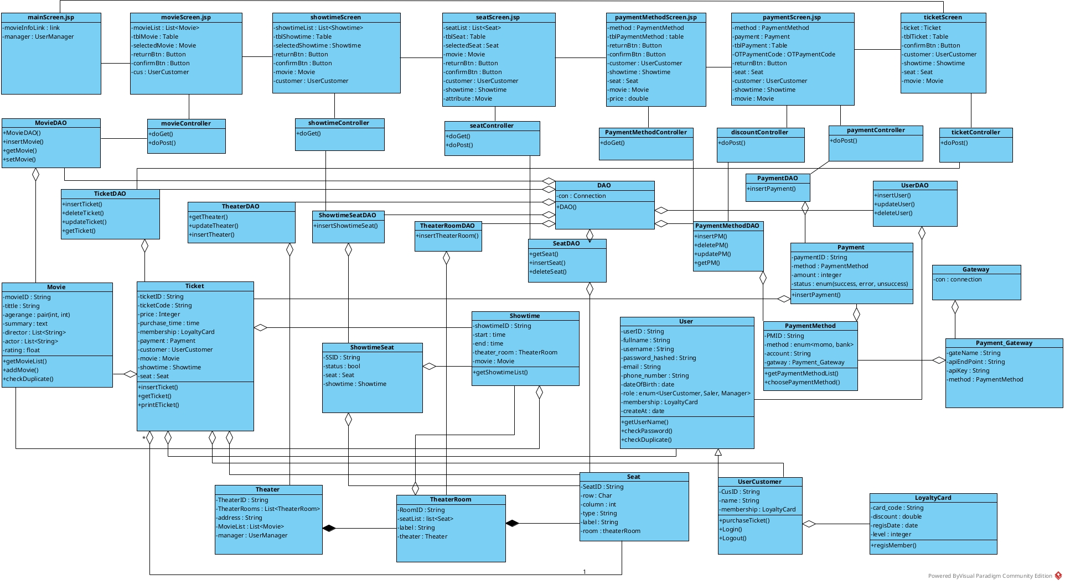

Packet diagram
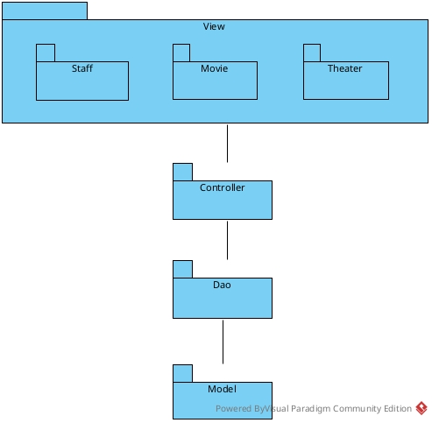

Deployment diagram
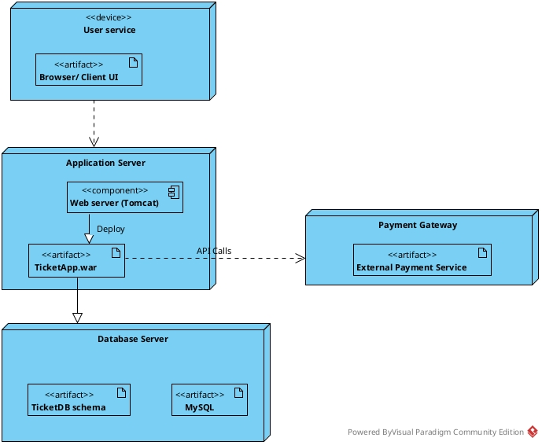

IV. Coding
Module add movie information
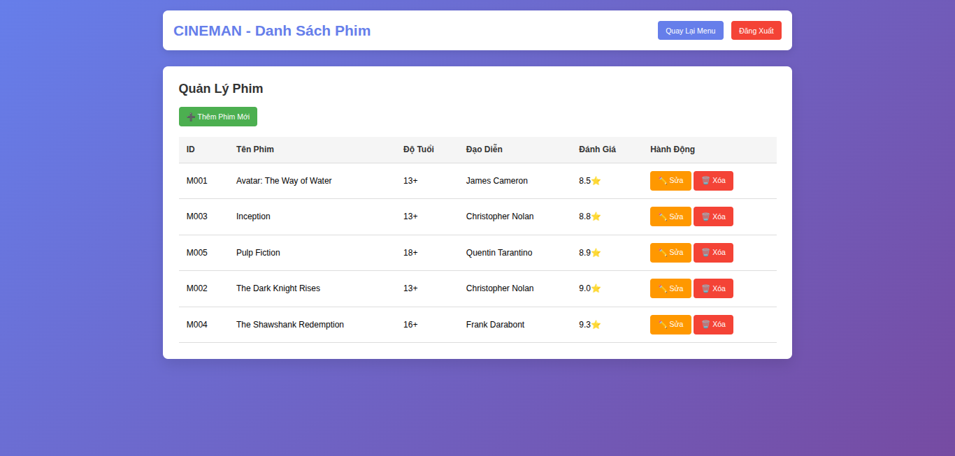
Movie list picture
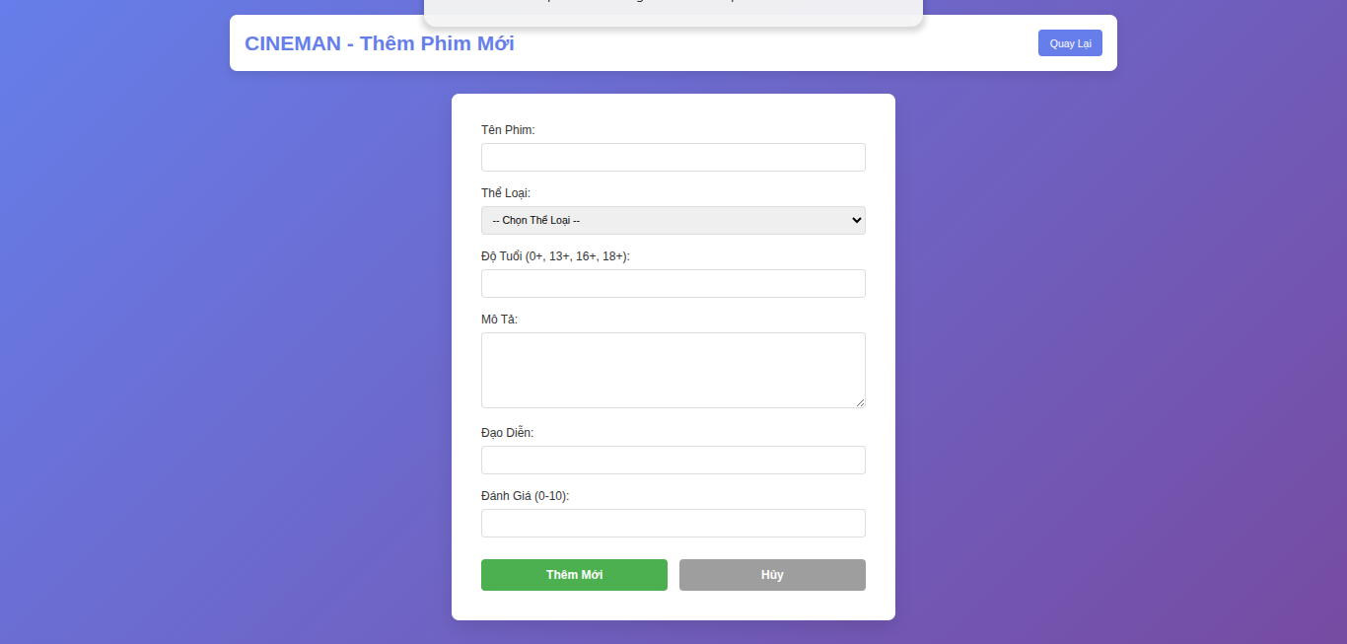
Add movie form

Result of movie added

Module purchase ticket online

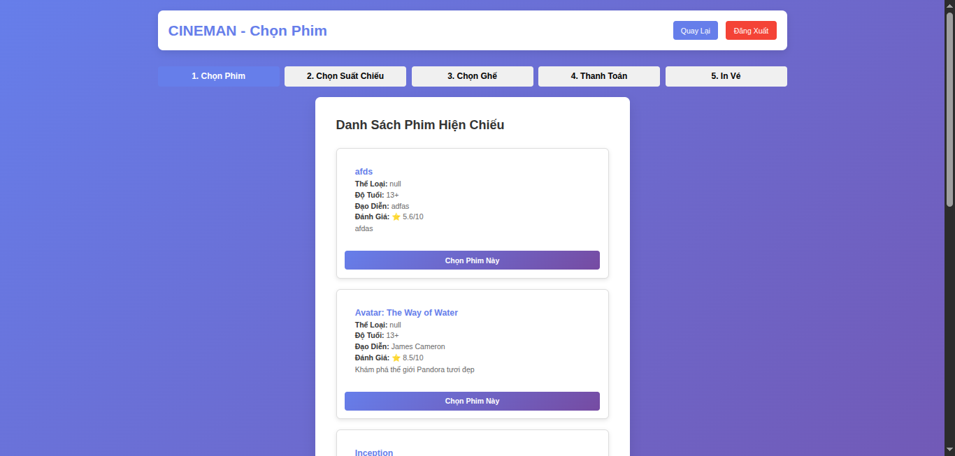
Movie list
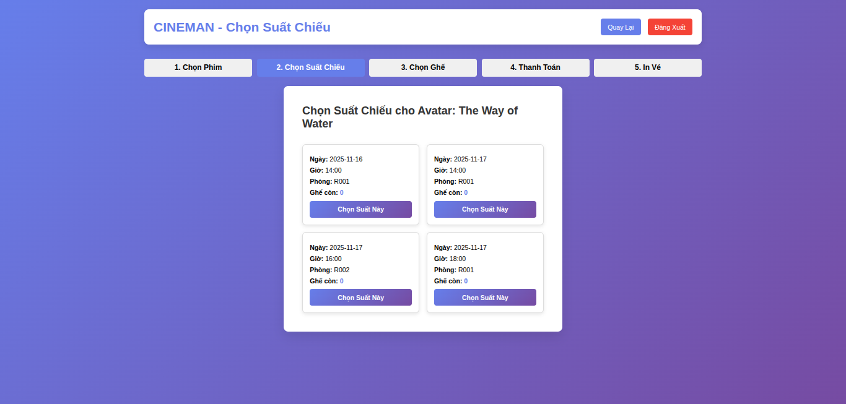
show time list
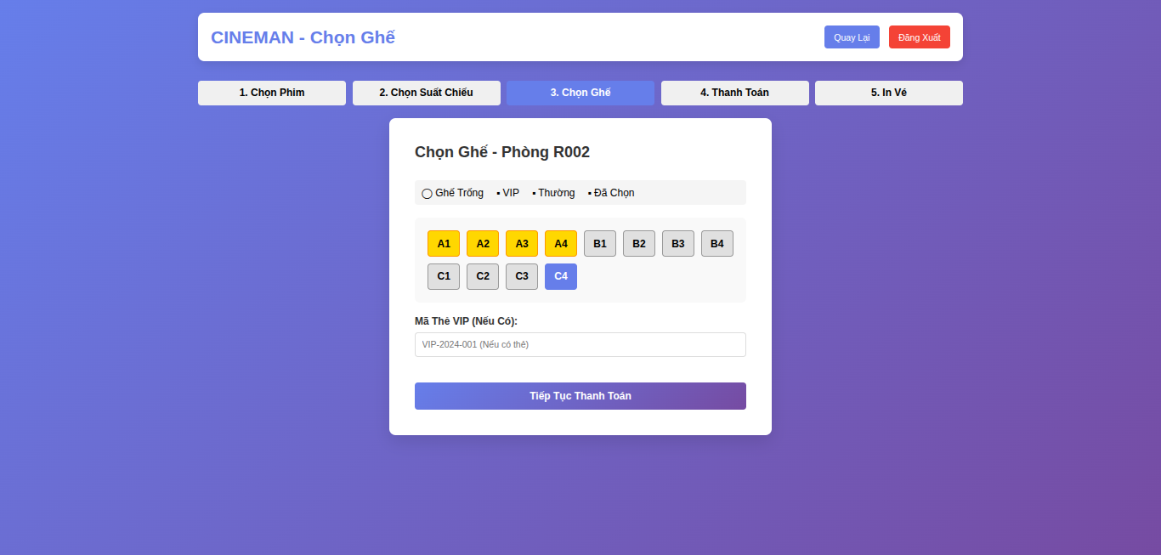
seat list to choose
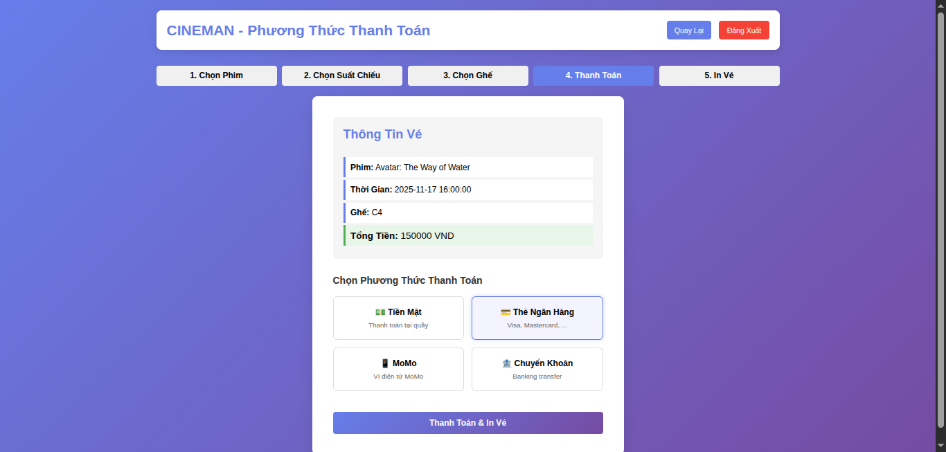
payment screen
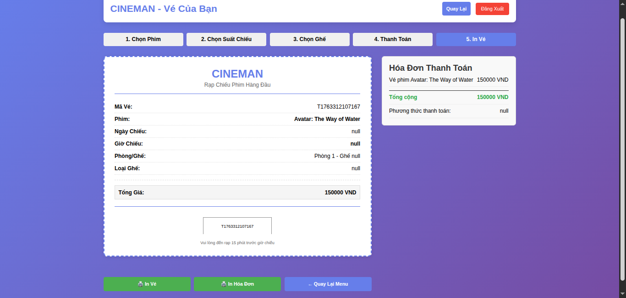
ticket screen

